CITY OF KAMIAH

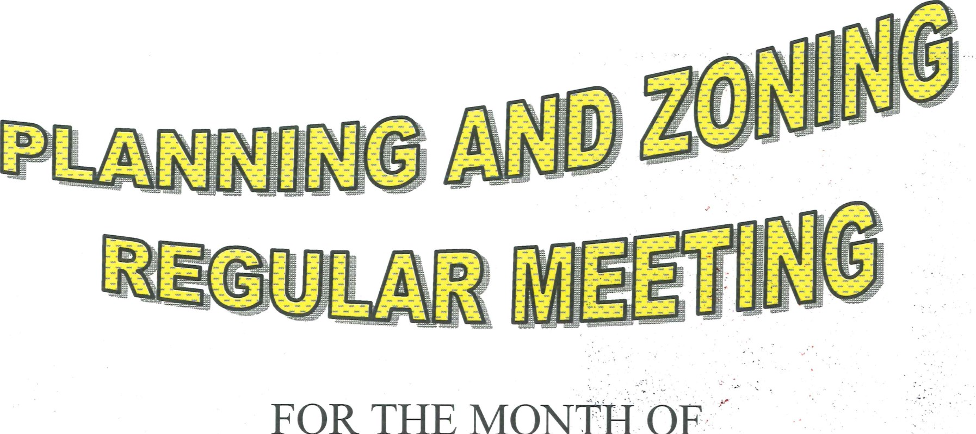

OF

October2016

HAS n

CANCELLED