**CITY OF KAMIAH PLANNING AND ZONING**

**PUBLIC HEARING**

**AUGUST 23, 2018**

**TIME: 7:00 PM**

**LOCATION: CITY HALL**

**GUESTS:** See sign-in sheet

**COMMISSION PRESENT:** Doug Warrington, Barbara Yates, Robbin Johnson, LuAnn Howard by phone

**PUBLIC HEARING OPENED:** 7:00 PM

**EXPLANATION OF THE HEARING PROCEDURES:** City Clerk Stephanie Gaston informed all participants of the public hearing procedure for conditional use permits. The applicant will make their presentation first, presentation by staff, written correspondence will be read, testimony supporting the application will be heard, make sure to state your name and address, testimony by those uncommitted to the application will then be heard, testimony by those opposed to the application will be heard. The applicant will have a chance for rebuttal and then the hearing will close.

**PRESENTATION BY APPLICANT BRIAN BROKOP:** Rhonda Wemhoff with Wemhoff Architecture presented to the Commission that the site has bee used as commercial residential for as long as the Owner can remember. The duplex that formerly occupied the space burned down last year. The Owner wishes to rebuild a duplex and add another duplex on the site to increase the number of rentals in which a conditional use permit is required. This site and the property adjoining to the north and across the alley to the east all have commercial residential structures. This use is a conditional use in C-1 Zone. The Owner wishes to continue this use. The two (2) new proposed duplexes will be constructed to new building code standards as well as be designed to compliment the neighbors and enhance the neighborhood. The new site design was planned with ease of maintenance in mind. This will allow the Owner to quickly tend the landscaping and street frontage. Onsite parking is screened by new construction. The neighboring uses are also residential, so the proposed (continued) use creates not hazard to current or future neighboring uses. Proposed (continued) use will be adequately served by all existing utilities. The design provides for one (1) additional duplex beyond the pre-fire use. Proposed (continued) use will not require any additional public costs. Proposed (continued) use done not change the current sue and therefore does not involve uses, processes or any type of conditions detrimental to any persons or the general publics welfare. Proposed (continued) use will have five (5) parking spaces allotted for the dwelling units in the alley, as shown on the site plan and proposed (continued) use does not alter or affect any natural scenic or historic features.

Brian Brokop also made statement, stating he feels there is a rental shortage in the area and this can help alleviate some of that problem. He also feels it is upgrading the area which could help raise property values.

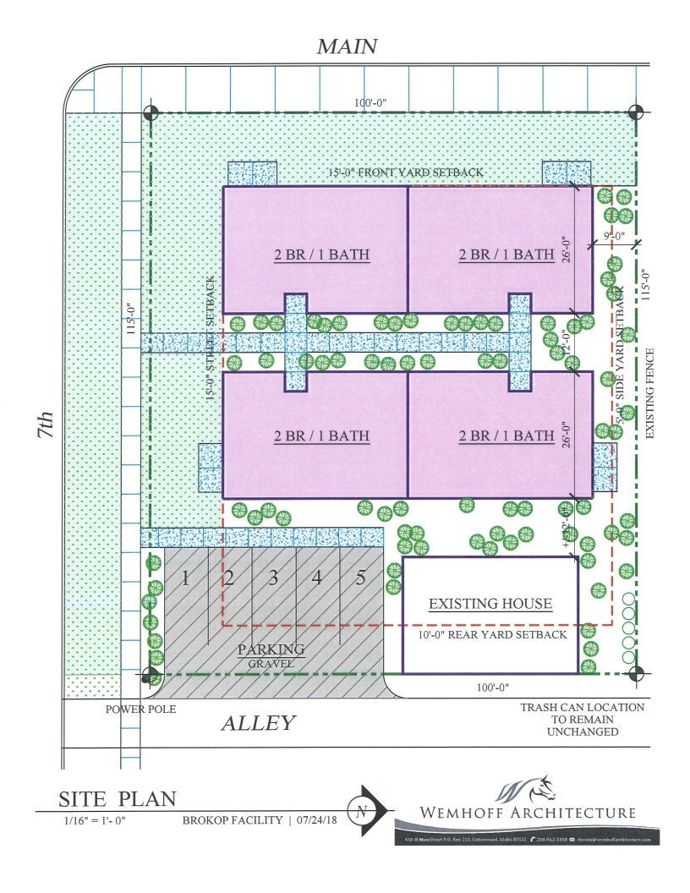

**PRESENTATION BY STAFF:** City Clerk Stephanie Gaston informed Commission she has read all ordinances and taken the site map and found that the site map appears to follow all City Ordinances.

**WRITTEN CORRESPONDENCE:** Dale Schneider wrote: Dear Stephanie, Concerning the public notice granting Brian Brokop a Conditional Use Permit to build two commercial/residential duplexes I have no objection as a resident within 300 feet. I feel it would help dress up Main St. and add to the tax base for the City. The one concern I have is will it have driveways or will it put four (4) more cars on the street. Sincerely, Dale Schneider.

**TESTIMONY BY THOSE SUPPORTING THE APPLICATION:** Marian Shepherd 608 Idaho St. testified she liked the idea. She thinks it will be wonderful to have nice new buildings for rentals. She did have one question, she wanted to know if the owners had to accept anyone who wants to rent the building. Barbara Yates stated, it depends on how you finance the property or if the property is financed through the government. There are some special programs. Marian stated she is supporting it.

**TESTIMONY BY THOSE UNCOMMITTED TO APPLICATION:** Tony Goetz 520 Main St., 514 8th St. stated, the only thing that has got me on the fence is we start using our commercial property up and somebody wants to put a business in we are gonna have a place on Main St. that is not going to have a business. That is the only thing. I don’t know if this town is going to grow but that is why I am kind of on the fence. Tony also had questions regarding the parking spaces. He read the ordinance as stating two parking spaces are need per each apartment. He inquired if this is still true? He stated off street parking is two. Tony also questioned the set backs from the alley. He thought they are to be 20 feet and not 11 feet.

**TESTIMONY BY THOSE OPPONENTS TO THE APPLICATION:** Tom and Virginia Arnold 607 Main St. testified he was against this Conditional Use Permit due to safety issues fire, the management and type of residents the Brokop Family allow to rent their properties. Mr. Arnold talked about specific tenants of the past. They also have concerns regarding the parking. Mr. Arnold also talked about the lights from the rentals would cause problems and the foot traffic this would bring to the area. Mr. Arnold feels the City needs to step up and take care of the riff-raff around. Mr. Arnold talked about the property lines and how the old duplex was only a foot from his property line because there are not survey markers. Mrs. Arnold would like the area surveyed to prove property lines. Mrs. Arnold was informed they would have to get a land survey to prove property lines.

Linda Hunter, 612 Maple St. she is a friend of the Arnolds and visits their location often. She reported she has had problems with the previous tenants. Mrs. Hunter is opposed to the Conditional Use Permit because she feels the property looks much nicer with just the one house being there. She also felt the property should be used for the elderly.

**REBUTTAL BY THE APPLICANT:** Rhonda Wemhoff address all question one at a time. She started with Tony Goetz question about parking and how many are required. She stated the ordinance address apartment units needing two parking spaces. Duplexes and single-family units do not require on-site parking per ordinance. They chose not to do apartment because they are not allowed in this area. They chose duplexes because they are allowed and do not require on-site parking nor fire suppression. Mr. Brokop will be providing 5 stalls for on-site parking and then there will be an additional 6-8 stalls depending on size on the street. They feel they have made a legitimate parking solution for the site.

Regarding the tenants Rhonda stated, they cannot control the renters. The units will be accessible.

Rhonda continued onto the question regarding property lines from Mr. and Mrs. Arnold. She stated, property lines are verified by this. The legal description of this property is 4 city blocks. We drew this plan according to the legal description. If Brian goes forward with this and there is a question about line I’m sure it will be worth the extra money to get the corners set.

Rhonda answered the setback question from Mr. Arnold and Mr. Goetz. She stated, Corner lot have additional setbacks to the street in which they get to choose what is their back yard. They went 10 feet off of the alley and 5 feet off the fence line from the North. Proposed new buildings are located within the legal setbacks. The existing building is located already right on the alley which they have no control over.

Mr. Brokop followed up stating they are building further away from the fence then the previous building was and that the Brokop Family does not manage the building across the alley that was referred to.

**PUBLIC HEARING CLOSED:** 7:42 PM

___________________________________ ___________________________________

Doug Warrington, President Stephanie Gaston, City Clerk/Treasurer